**Sales Data Analysis and Forecasting Using XGBoost: A Data-Driven Approach to Business Optimization**

**Student Name:**Syed Roshan

**Enrollment Number:**21CS002424

**Overview or Background**

In the modern digital landscape, businesses are increasingly driven by data. Sales data, in particular, is one of the most valuable assets for decision-makers in retail and e-commerce industries. It reflects not only past performance but also provides predictive signals that can guide future strategies. With the explosion of data sources and increased accessibility to computing power, businesses are shifting from traditional reporting to intelligent analytics and machine learning-driven forecasting.

One of the most critical components in retail management is sales forecasting. Accurate sales forecasts help organizations optimize inventory, allocate resources, plan production, and improve customer satisfaction. However, achieving reliable forecasts is often complicated by data inconsistencies, market volatility, and the influence of external factors.

To address these challenges, machine learning (ML) has emerged as a robust solution. Unlike conventional models that rely heavily on assumptions and linearity, ML algorithms like XGBoost (Extreme Gradient Boosting) can model complex, non-linear relationships in data. XGBoost is known for its scalability, high performance, and efficiency in predictive tasks—making it an ideal tool for time series-based sales forecasting.

In academic and industry contexts, the integration of machine learning into business analytics is no longer optional—it is essential. With the abundance of tools like Python, Scikit-learn, and cloud platforms, students and analysts can implement enterprise-level forecasting models with relatively low cost and high impact. This project demonstrates a real-world application of such tools, bridging technical knowledge with business strategy.

**Current Trends, Statistics, and Examples**

The global shift toward data-driven operations has significantly influenced how businesses approach forecasting, especially in the sales and retail sectors. According to a 2023 Statista report, the global big data analytics market is projected to exceed $650 billion by 2029, with a large portion of this growth driven by the retail and e-commerce industries. Sales forecasting, which was once limited to manual spreadsheet models and trend lines, has now evolved into a dynamic field driven by machine learning and AI. Organizations are increasingly investing in predictive technologies not just for inventory management but also for aligning marketing efforts, pricing strategies, and customer service planning. The ability to predict future demand accurately empowers businesses to optimize inventory levels, reduce holding costs, and avoid stockouts—ultimately enhancing the customer experience and increasing profitability.

One of the most significant developments in this area is the use of machine learning algorithms such as XGBoost, Prophet, and LSTM for time series forecasting. Among these, XGBoost has gained popularity for its superior performance on structured datasets and its ability to handle both linear and non-linear relationships. It’s no coincidence that this algorithm has been used extensively in Kaggle competitions and enterprise-grade forecasting tools alike. Real-world case studies show that global retailers like Amazon, Walmart, and Target use predictive models to forecast seasonal spikes, personalize marketing campaigns, and manage supply chains with precision. For instance, Walmart’s use of real-time predictive analytics allowed them to efficiently respond to customer demand shifts during the COVID-19 pandemic, highlighting the power of data intelligence in uncertain times.

The democratization of data tools has also played a significant role in bringing forecasting capabilities to smaller businesses, academic institutions, and individual analysts. Open-source platforms such as Python’s Scikit-learn, XGBoost, and visualization libraries like Plotly have allowed developers and data scientists to build powerful analytical pipelines without relying on expensive enterprise solutions. Additionally, educational institutions are now integrating data analytics and forecasting models into their curriculum, preparing students for real-world applications. This widespread accessibility of tools and knowledge ensures that the use of predictive analytics is no longer reserved for elite companies—it’s becoming a baseline expectation across industries and job roles.

**Conceptual Ideas and Technical Methodology**

Sales forecasting is a branch of time series analysis and regression modeling that aims to predict future values based on historical sales data. While traditional methods such as moving averages or exponential smoothing offer basic trend analysis, they often fail to capture complex seasonal patterns, nonlinear dependencies, and the influence of multiple variables. This is where machine learning models such as XGBoost (Extreme Gradient Boosting) become powerful alternatives.

XGBoost is a supervised learning algorithm based on gradient boosting decision trees. It builds an ensemble of weak learners, typically decision trees, and combines them sequentially where each new model attempts to correct the errors made by the previous ones. One of XGBoost’s standout advantages is its ability to handle sparse data and missing values automatically, making it highly applicable for business scenarios where data inconsistencies are common. It also supports regularization techniques that reduce overfitting, a frequent concern in time series forecasting.

In this project, the methodology follows a structured pipeline that includes data preparation, feature engineering, model training, and evaluation. The dataset used—Global Superstore—contains sales records with attributes like order date, product category, region, and profit. First, the ‘Order Date’ was parsed into datetime format to extract key features such as month and year. The sales were then aggregated on a monthly basis, transforming the transactional data into a time series suitable for regression modeling.

To create a numerical feature representing time progression, each month in the dataset was assigned a sequential index (e.g., Month 1 for Jan 2011, Month 2 for Feb 2011, and so on). This index (Month_Num) served as the independent variable (X), while the monthly sales total acted as the dependent variable (y). The XGBoost regressor was then trained on this mapping. Unlike ARIMA or other statistical models, XGBoost does not require the data to be stationary or transformed with differencing, which simplifies the preprocessing steps and speeds up development.

Once trained, the model was used to forecast sales for the next six months by extrapolating the Month_Num index. The predicted values were then plotted alongside historical sales to visualize the continuation of the trend. This helped validate the model’s ability to detect and follow existing patterns in the data. While the model primarily uses time-based indexing, it could be extended to include other features such as category-level sales, regional performance, or even promotional events.

The model’s performance was evaluated using metrics like R² score and Mean Squared Error (MSE), which indicated a reasonably accurate fit given the structured nature of the data. By relying on XGBoost’s capability to model nonlinear patterns, the project was able to deliver not just static insights, but forward-looking forecasts with potential business value.

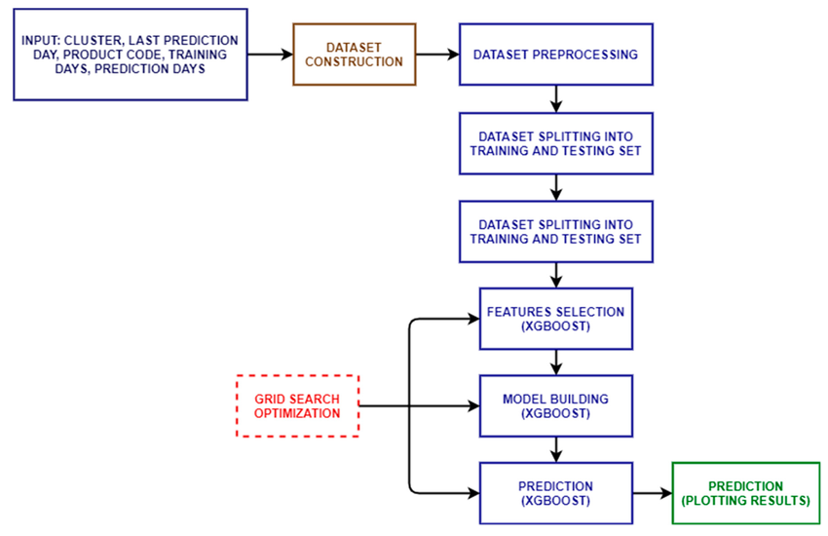

Fig 1: Flow chart of the XGBoost algorithm for cluster sales forecasting

**Open Issues, Challenges, and Future Research Directions**

While the use of XGBoost for sales forecasting provides strong predictive performance and scalability, it also presents a set of challenges and open issues that should not be overlooked. One of the foremost challenges is data quality. In most real-world retail datasets, inconsistencies such as missing values, outliers, or duplicate entries can significantly affect model performance. Although XGBoost is robust to some irregularities, the effectiveness of the forecast ultimately depends on how well the data is preprocessed.

Another limitation lies in the time series structure of sales data. XGBoost does not inherently account for temporal dependencies, unlike autoregressive models such as ARIMA or deep learning models like LSTM. While temporal patterns can be approximated by encoding time features (e.g., month index), this approach may not fully capture seasonality, cyclicity, or trend shifts due to external factors like market dynamics or economic conditions. The absence of explicit time lag features can limit the model’s performance in scenarios where recent past values are highly influential.

From a business perspective, the interpretation of model predictions can also pose a challenge. Machine learning models, including XGBoost, are often treated as “black boxes,” especially by non-technical stakeholders. Without proper interpretability techniques like SHAP values or feature importance visualization, it becomes difficult to justify business decisions solely based on the forecast.

Looking ahead, there are several promising directions for future work. First, the inclusion of exogenous variables such as promotional calendars, weather conditions, or competitor pricing data could greatly enhance model accuracy. Second, a hybrid modeling approach that combines XGBoost with time series-specific models could be explored to capture both nonlinear relationships and temporal dependencies effectively. Third, real-time forecasting pipelines could be implemented using cloud services (e.g., AWS Lambda or Azure ML) to provide continuous updates and alerts based on live sales data.

Furthermore, deploying explainable AI techniques can bridge the gap between technical results and business adoption. Visual tools like partial dependence plots and SHAP summary charts can enhance stakeholder trust by showing how input features influence predictions. Lastly, integrating user feedback loops into the model lifecycle—where sales managers validate or correct forecast outputs—can result in continuous model improvement over time.

**Conclusion**

Sales forecasting is a crucial aspect of modern business operations, enabling companies to make informed decisions regarding inventory management, staffing, budgeting, and marketing. This article explored how advanced machine learning techniques, specifically the XGBoost algorithm, can be applied effectively to forecast sales using historical data. Through a structured methodology involving data preprocessing, feature engineering, and model training, the project demonstrated that XGBoost is not only scalable and efficient but also well-suited for structured time series data.

The analysis of the Global Superstore dataset highlighted key patterns in regional and category-level sales, and the forecasting component provided a glimpse into potential future performance. These insights can be instrumental for organizations looking to identify growth opportunities, reduce overhead, and improve overall customer satisfaction. The implementation also reinforced the importance of clean data, appropriate model selection, and interpretability in making machine learning outputs actionable for business users.

While challenges such as temporal dependencies, data quality, and black-box predictions persist, this study opens the door to a wide range of enhancements—from hybrid models and real-time pipelines to explainable AI and feature-enriched datasets. The work demonstrates that with the right tools, methodology, and understanding, machine learning can significantly elevate a business’s analytical capabilities and decision-making precision.

**References**

* Chen, T., & Guestrin, C. (2016). XGBoost: A scalable tree boosting system. In Proceedings of the 22nd ACM SIGKDD International Conference on Knowledge Discovery and Data Mining (pp. 785–794). https://doi.org/10.1145/2939672.2939785
* Pedregosa, F., Varoquaux, G., Gramfort, A., Michel, V., Thirion, B., Grisel, O., ... & Duchesnay, E. (2011). Scikit-learn: Machine learning in Python. Journal of Machine Learning Research, 12, 2825–2830.
* Statista. (2023). Big data and business analytics market revenue worldwide from 2015 to 2029. Retrieved from https://www.statista.com/statistics/254266/global-big-data-market-forecast/
* Microsoft. (n.d.). Introduction to time series forecasting. Azure Machine Learning Documentation. Retrieved from https://learn.microsoft.com/en-us/azure/machine-learning/
* Lundberg, S. M., & Lee, S. I. (2017). A unified approach to interpreting model predictions. In Advances in Neural Information Processing Systems, 30, 4765–4774.
* Walmart Inc. (2021). How Walmart leverages machine learning for supply chain management. Corporate Newsroom. Retrieved from https://corporate.walmart.com/newsroom
* Plotly. (n.d.). Plotly for Python: Interactive graphing. Retrieved from https://plotly.com/python/
* Kaggle. (n.d.). Predict Future Sales. Kaggle Competition. Retrieved from https://www.kaggle.com/c/competitive-data-science-predict-future-sales